DDL Commands
1.Alter-add new column
ALTER TABLE Book
ADD Price DECIMAL(10,2);
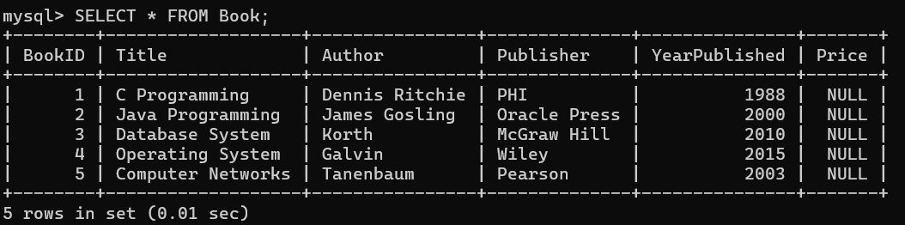
2.Rename column
ALTER TABLE Book
RENAME COLUMN Title TO BookTitle;
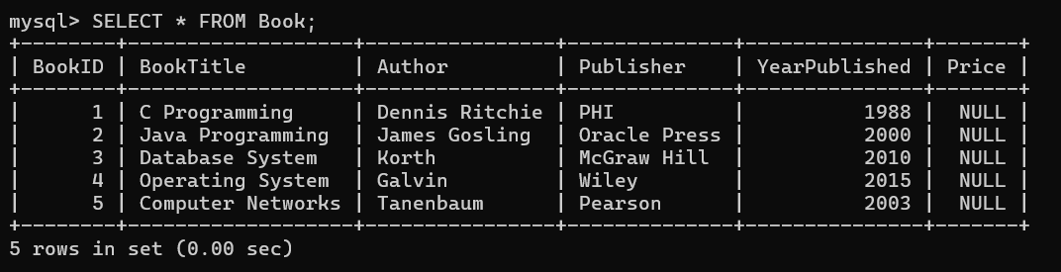
3.DROP column
ALTER TABLE Book
DROP COLUMN Price;
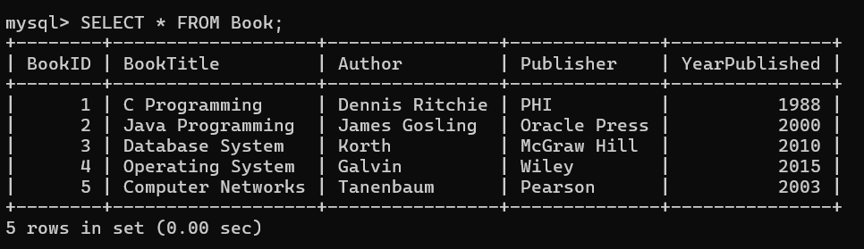

4.TRUNCATE
TRUNCATE TABLE Book;







0

5.DROP table
DROP TABLE Book;
Table deleted permenantly

DML Commands
1.INSERT
INSERT INTO Book (BookID, BookTitle, Author, Publisher, YearPublished)
VALUES (6, 'Computer Graphics', 'Donald Hearn', 'Pearson', 2011);
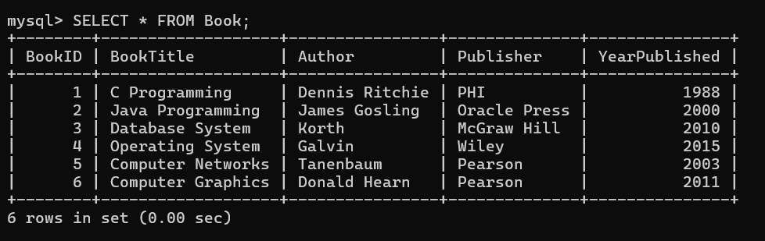
2.SELECT
SELECT * FROM Book;

3.UPDATE
UPDATE Book
SET Publisher = 'Pearson'
WHERE BookID = 3;
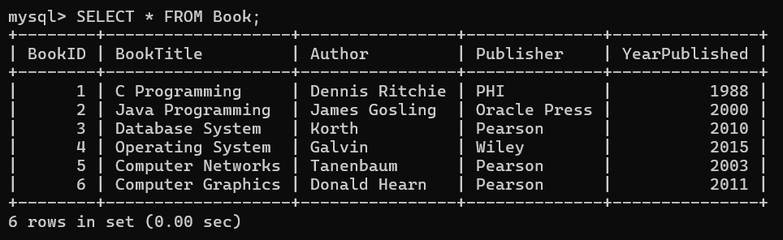

4.DELETE
DELETE FROM Book
WHERE BookID = 6;
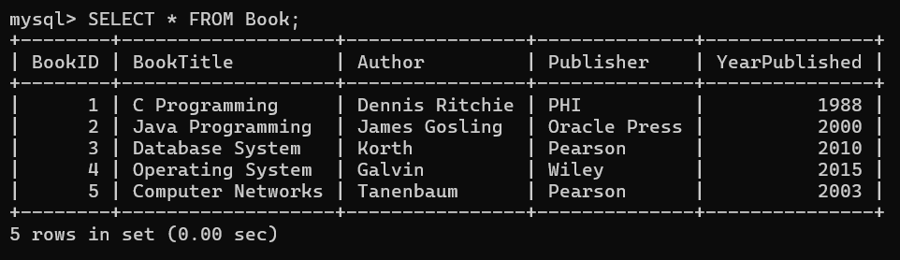
5.SEARCH
SELECT * FROM Book
WHERE Publisher = 'Pearson';
